UNDERSTANDING ETHICS PROCEDURES
COSHH Risk Assessment Form
It is a legal health and safety requirement that a supplier of a substance/chemical must identify whether or not it has any hazardous properties. If the supplier concludes that the substance/chemical could cause harm, they must also tell you what the hazards are and how to avoid them. This information should be made available via product labelling and a safety data sheet (SDS) that contains the information necessary to enable the completion of a risk assessment, as required by the Control of Substances hazardous to Health Regulations (COSHH).
The following risk assessment must be completed before any hazardous substance/chemical is to be used, however small the hazard is. You should refer to the suppliers packaging and SDS, which will describe the hazards that exist, and must assess the probability of those hazards arising when the substance/chemical is in use. You must also identify suitable countermeasures to protect the user from any level of harm.
Your completed COSHH Risk Assessment must be submitted alongside your ethics approval application and must be strictly adhered to at all times.

Substance |  | Date
Activity/Task Description
Duration |  | COSHH Assessor Name

Risk Identification
Hazards | Who could be affected? | Level of risk |  |  | Comments
 |  | Low | Medium | High
e.g. Irritating and/or obstructive to respiratory system | e.g. Operatives | ☐ | ☐ | ☐ | e.g. Avoid inhalation. Wear mask if excessive dust. Ensure adequate ventilation
 |  | ☐ | ☐ | ☐
 |  | ☐ | ☐ | ☐
 |  | ☐ | ☐ | ☐
 |  | ☐ | ☐ | ☐

Classification
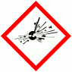  ☐  Explosive | 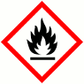  ☐  Flammable | 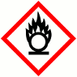  ☐  Oxidising | 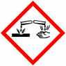  ☐  Corrosive | 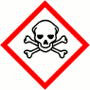  ☐  Acute Toxicity
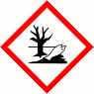  ☐  Hazardous to the Environment | 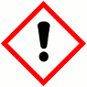  ☐  Health Hazard to the Ozone Layer | 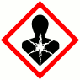  ☐  Serious health hazard | 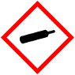  ☐  Gas under pressure

Controls
Type of Control | Control Measures | Control Measures Actioned
e.g. Usage | e.g. Limit duration of exposure.  Ensure area is always well ventilated.  Wherever possible, use dust extraction equipment.  Always wear a dust mask.  Do not smoke, eat or drink in the areas. | Signed and dated

